Abstract submission for:

“MagIC - Magnetism, Interactions and Complexity: a multifunctional aspects of spin wave dynamics”

(2-7 July 2017, Poznań - Trzebaw, Poland)

Contact details of the presenting author:

Surname:
First name:
Academic level: 󠄀
Institution:
Email:
Do you prefer oral or poster session?

About talk and poster session:

Experienced researchers and PhD students will have preference in oral sessions, while master's and undergraduate’s students will have preference for poster session. Availability of slots depends on the preference and demand of participants.

Please scroll down for a sample abstract on the following page.
Note: The length of the abstract should not exceed one page.

This is the Style Guide for your Abstract
(title is bold, 14-point type, centered, with capitals)

X. Author¹, Y. Author¹, Z. Author² (Author name(s) [11-point type, bold, centered])
Authors’ affiliation and full address (9-point type, centered, italics)
Corresponding Author’s e-mail address and URL: (9-point type, centered, italics)

Key words: Force measurement, vortices, live cells, holographic optical tweezers.

Insert the text of your abstract here. The abstract including title, figure, references, etc. must not exceed one page. Use Letter paper format. Set all margins (left, right, top, bottom) to 25 mm. The text should be written in a 12 pt Times New Roman font.
Except for the first, new paragraphs should start with an indent. References should be cited in “footnote fashion” using a superscript. The references should be typed in a 10-point Times New Roman font in the format used below.

Please include one figure highlighting your contribution.

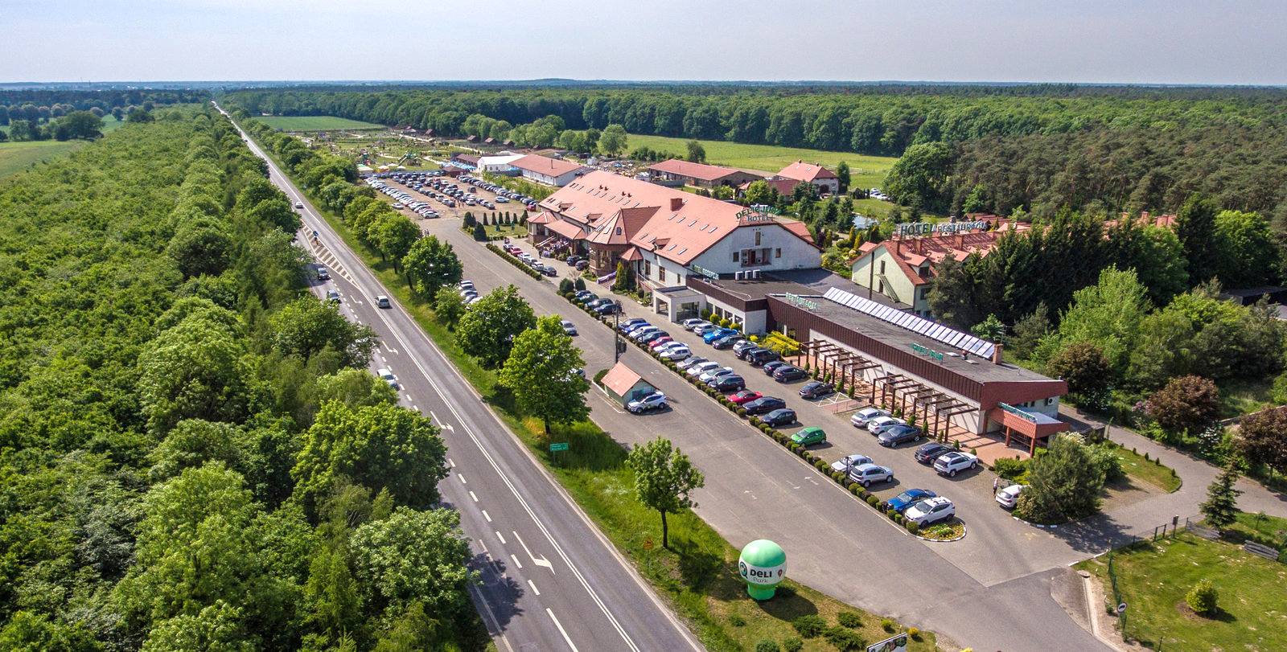
The figure caption should be typed in a 10 pt font size, it is centered.

Save and submit your contribution as a PDF-file!

[1] A. Author, A. Nother, and C.O. Author, Title, Journal 12, 3456 (2017)

Citation of a journal article: A. Ashkin, Phys. Rev. Lett., 24 (1970) 156-159.

